Nama : Jefri Haris Laksmana  
NIM : 18090025  
Kelas : 5D  
  
Laporan Praktikum 3

1. Source Code

view-form-matakuliah.php -> application/views/

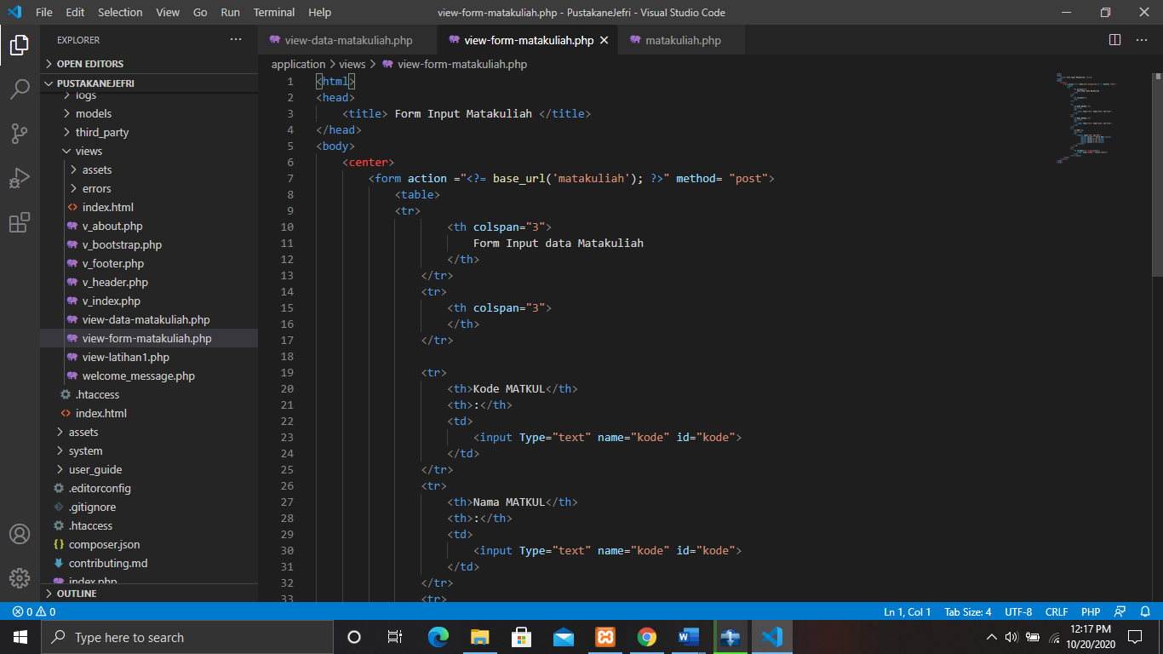

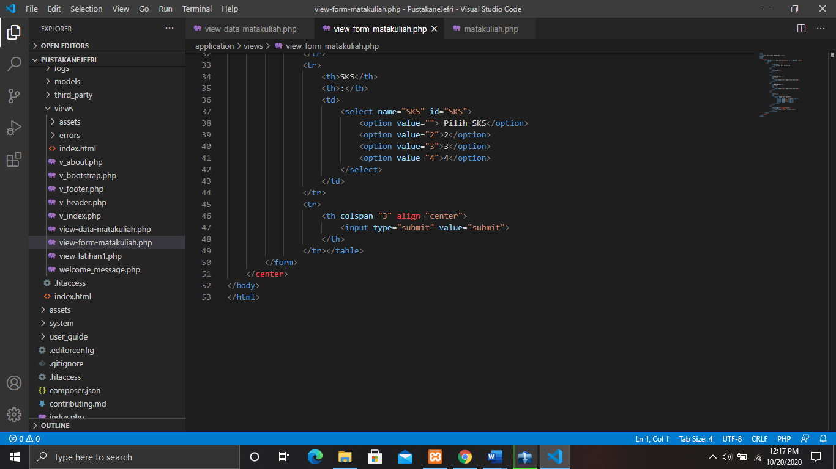

view-data-matakuliah.php -> application/views/

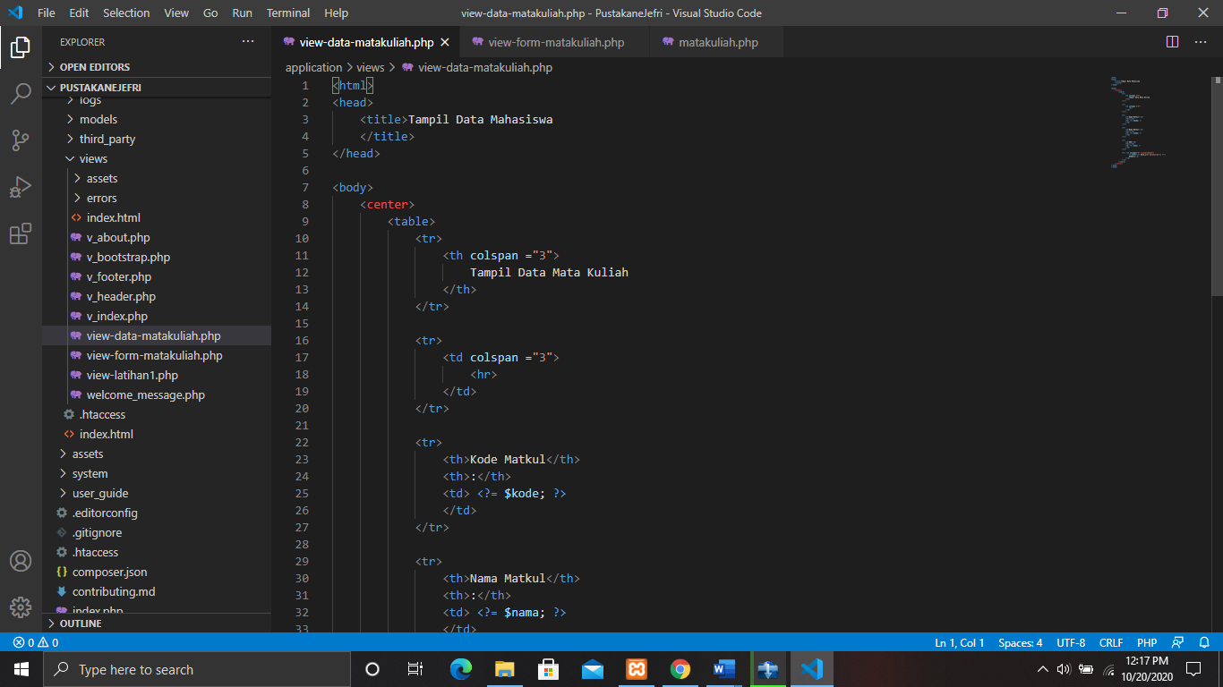

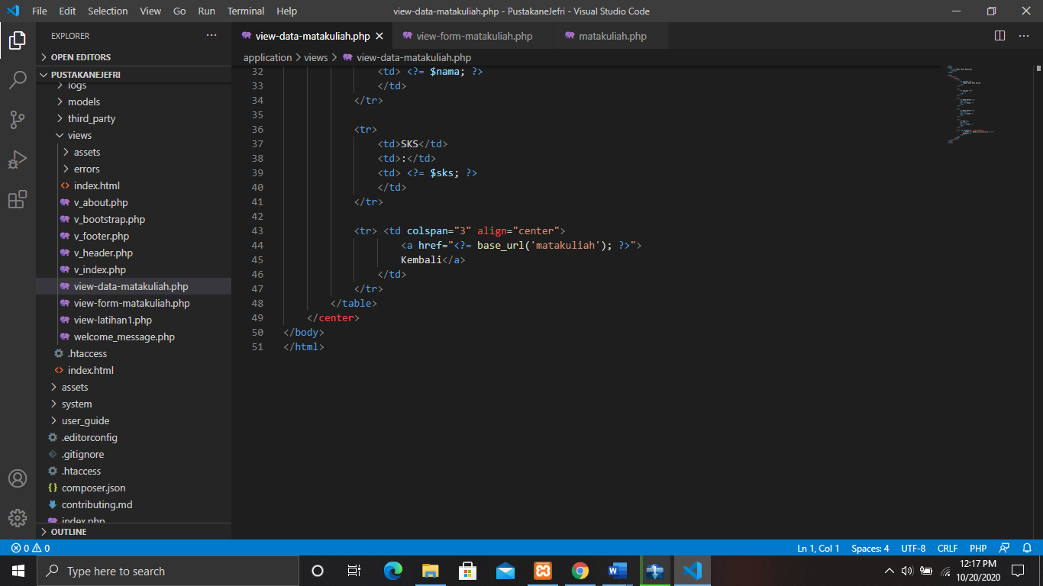

matakuliah.php -> application/controller/

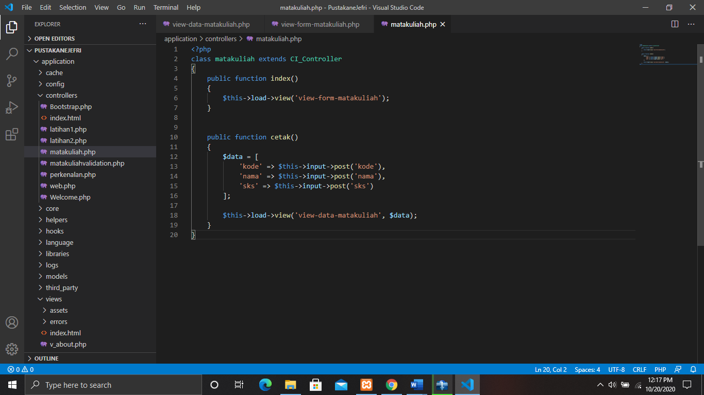

1. URL

<http://localhost/PustakaneJefri/matakuliah>

1. Capture Output Program

